GRAPHITE ENERGY INC.
11575 City Hall Promenade, Miramar, FL 33025 USA

GRAPHITE ENERGY INC.  11575 City Hall Promenade,  Miramar, FL 33025 USA | Dominik Georg Luh  TECHNOGRAFIT GmbH  Rosengasse 1, D-65343  Eltville  Germany
SALES CONTRACT | N° 113/26 | Date 28/02/2026 | P.O. No. E-18457
IN ACCORDANCE WITH OUR AGREMENTS WE ARE CONFIRMING BY THE PRESENT CONTRACT, THE FIRM SALE OF THE FOLLOWING GOODS AS AGREED WITH YOUR COMPANY UNDER THE FOLLOWING CONDITIONS:
Description of Goods
Graphite from Madagascar

Item | Quantity | Unit Price  CFR  ANTWERP | Sub-Total | Specification
PWD -194 | 100 MT | USD570 | USD 57,000 | LOI Carbon: 94%MIN, Ash: 6%MAX  Moisture: 0.5%MAX.  Size: Minus sieve 100mesh 80%MIN.  Minus sieve 325mesh 30%MAX.
Total Amount | 100 MT |  | USD 57,000 | Packed in 1000kg big bags. Top tier free without pallet, bottom tier with pallet, only bottom tier fixed on pallet with straps.

Payment
100 % Payment within 7 days after date of BL by transfer to our bank account with:
Beneficiary | Graphite Energy Inc.
Bank data of the beneficiary | Bank of America
 | Address: 222 Broadway, New York, NY 10038
 | SWIFT: BOFAUS3N
 | Account No. 4350 5911 9245
Message/ Reference to be specified with the transfer | Invoice(s) No….

Times of Shipment Dispatch from Tamatave late March 2026.

Destination

ANTWERP, BELGIUM

Insurance

Maritime insurance to be covered by the Purchaser from Vendor's warehouses to Purchaser's warehouses.

Specific Conditions
- Shipping Line : MSC
- Documents : SEAWAY BILL - Invoice - Analysis sheet – Packing list
- Bills of Lading : Consignee : Dominik Georg Luh Technografit Gmbh, Rosengasse 1, D-65343, Eltville, Germany,
E-Mail: dunjapiedl@technografit.de
Notify party: SAME AS CONSIGNEE
- Big Bags marking:
Graphite GP 94/96
REF 7149

- Delivery note :
Graphite Energy shall be informed of any changes to the above times of delivery at least one clear month before loading.

General Conditions
This CFR sale is subject to the International Chamber of Commerce Incoterms.

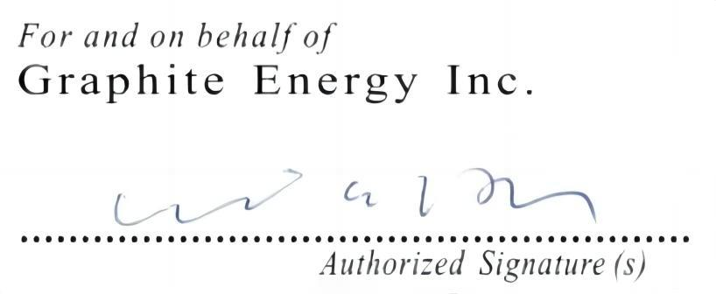
Purchase accepted by Purchasers Sale accepted by Vendors

